Setup and Use a Firewall on Windows/Linux

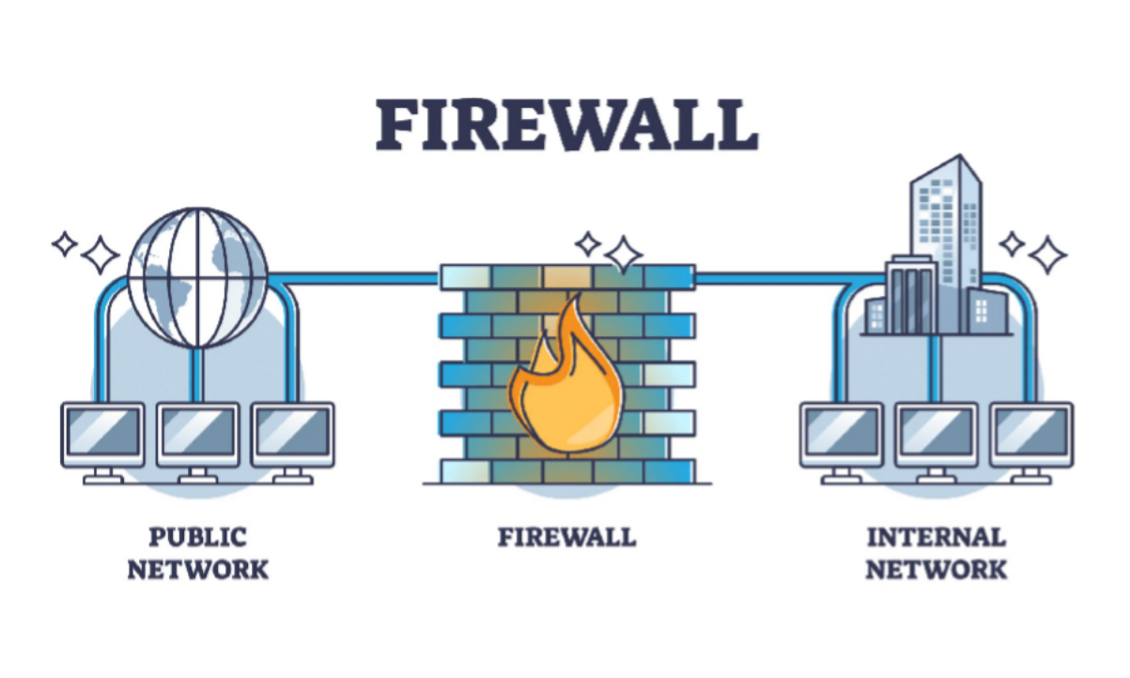

We setup and use firewall on Linux.

Open Firewall Configuration Tool

On Linux (UFW):

Open firewall configuration tool (Windows Firewall or terminal for UFW)

Open a terminal and run “sudo ufw status” to check if it's active. If not, enable it with “sudo ufw enable”.

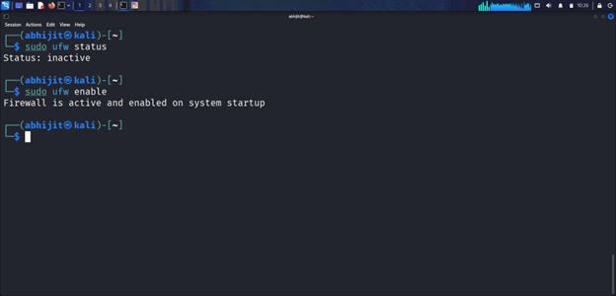

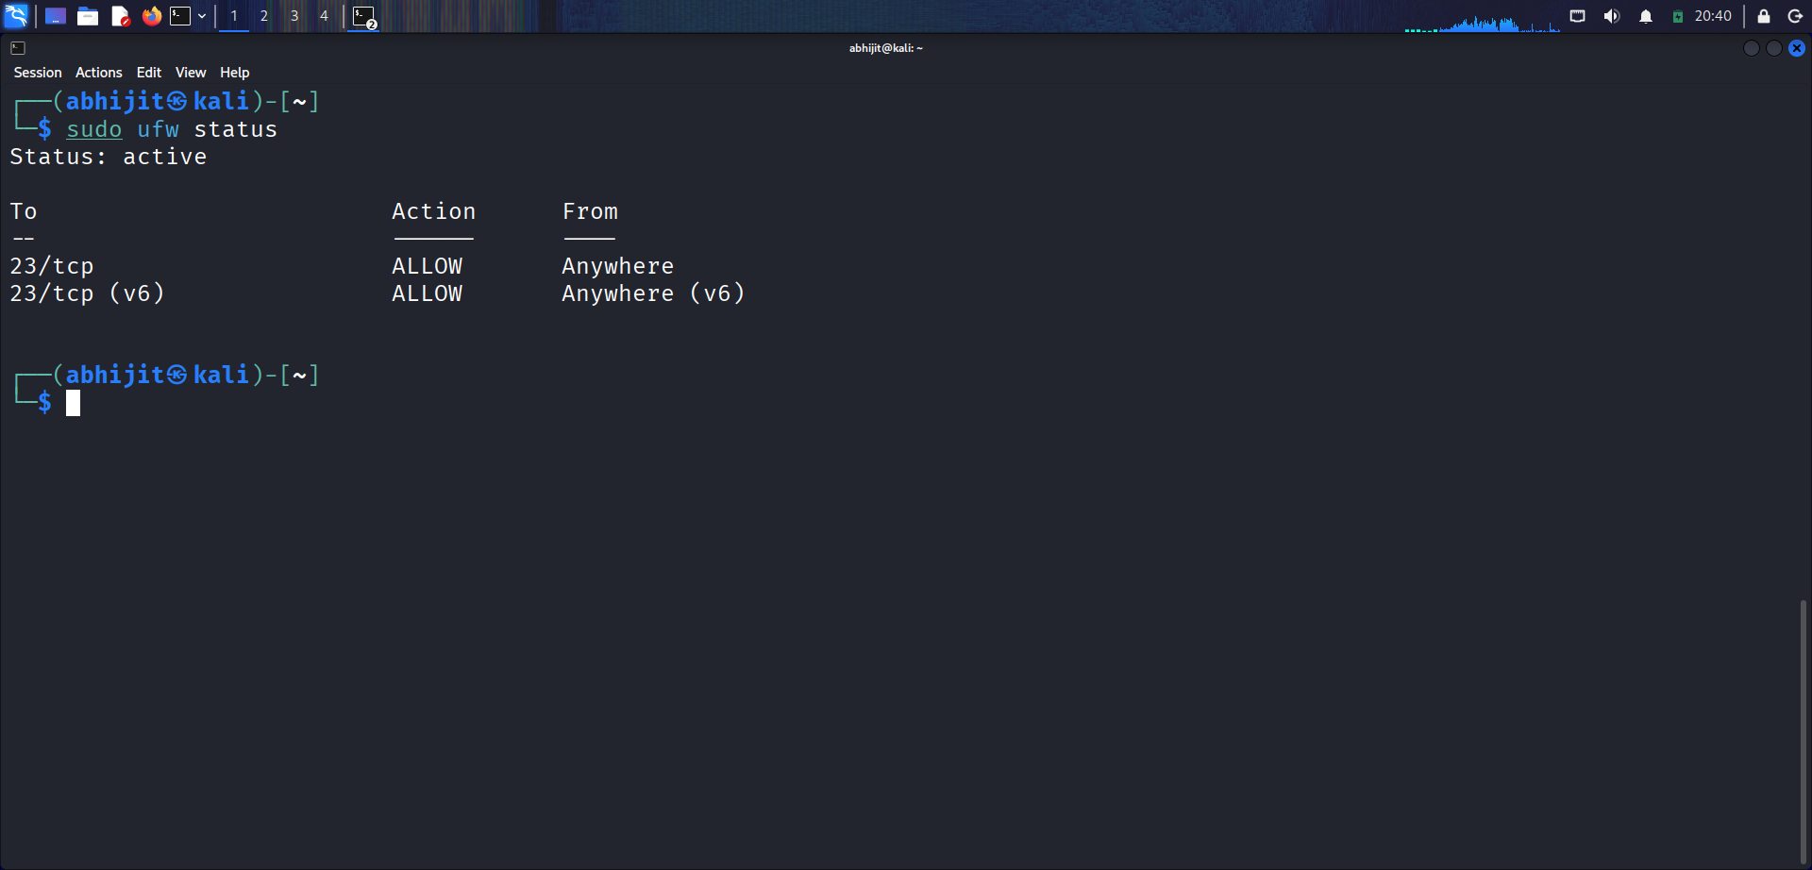

List Current Firewall Rules

On Linux (UFW):

Run “sudo ufw status verbose” in the terminal. This lists active rules, including allowed/denied ports and directions (e.g., "22/tcp ALLOW IN Anywhere").

First status 22/tcp Deny

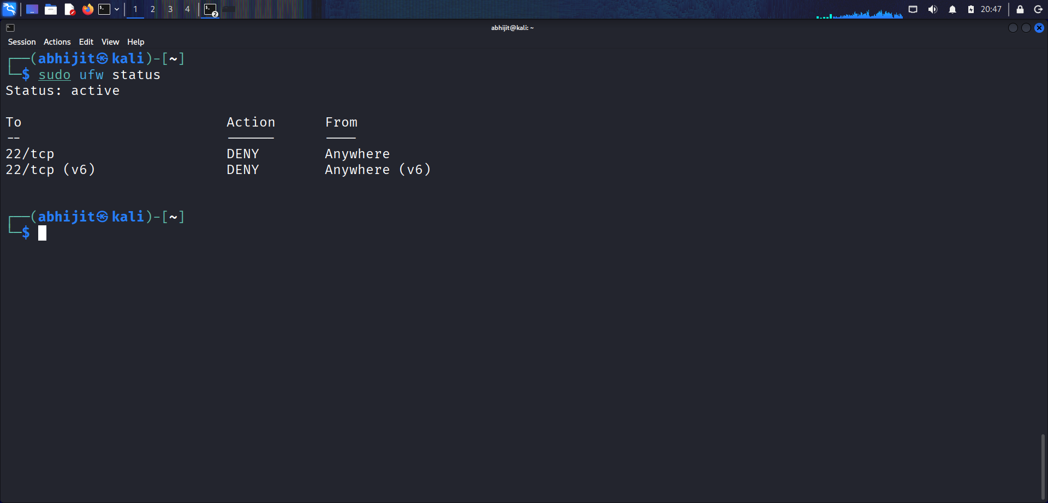

Then Allow 22/tcp

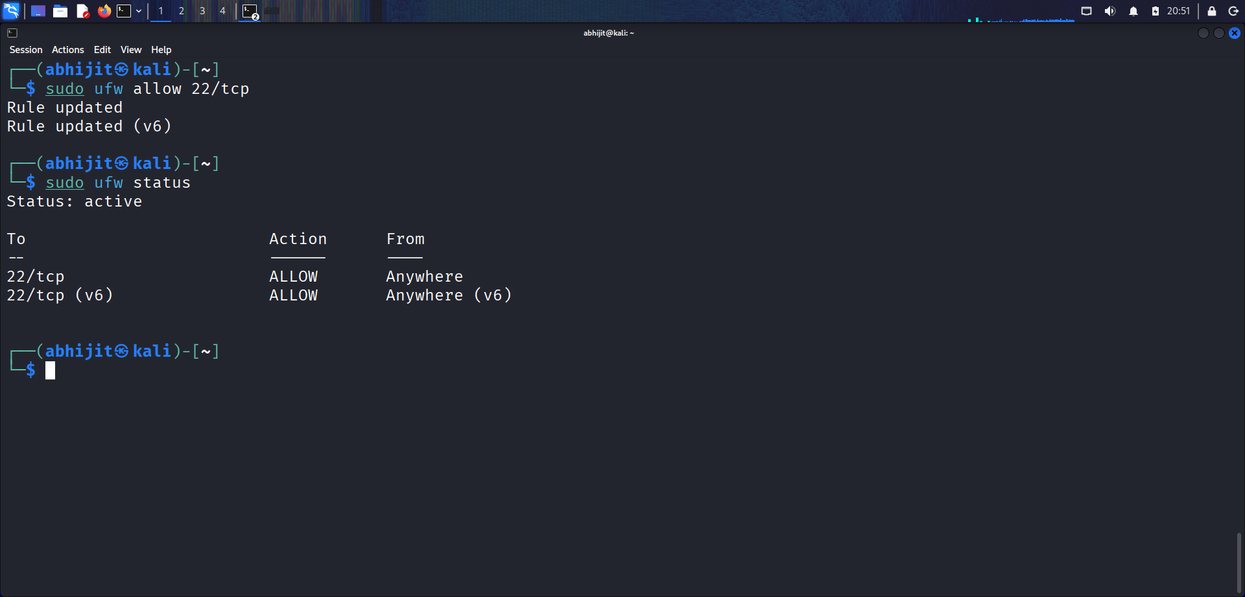

Add a Rule to Block Inbound Traffic on a Specific Port (e.g., 23 for Telnet)

On Linux (UFW):

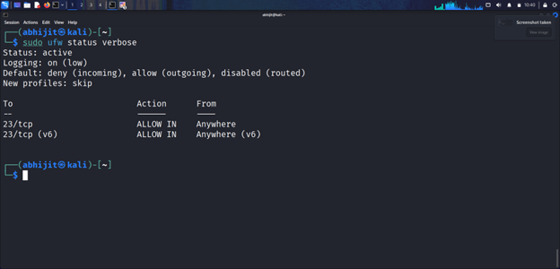

Run “sudo ufw deny 23/tcp” (this blocks inbound on port 23). To confirm, run “sudo ufw status”.

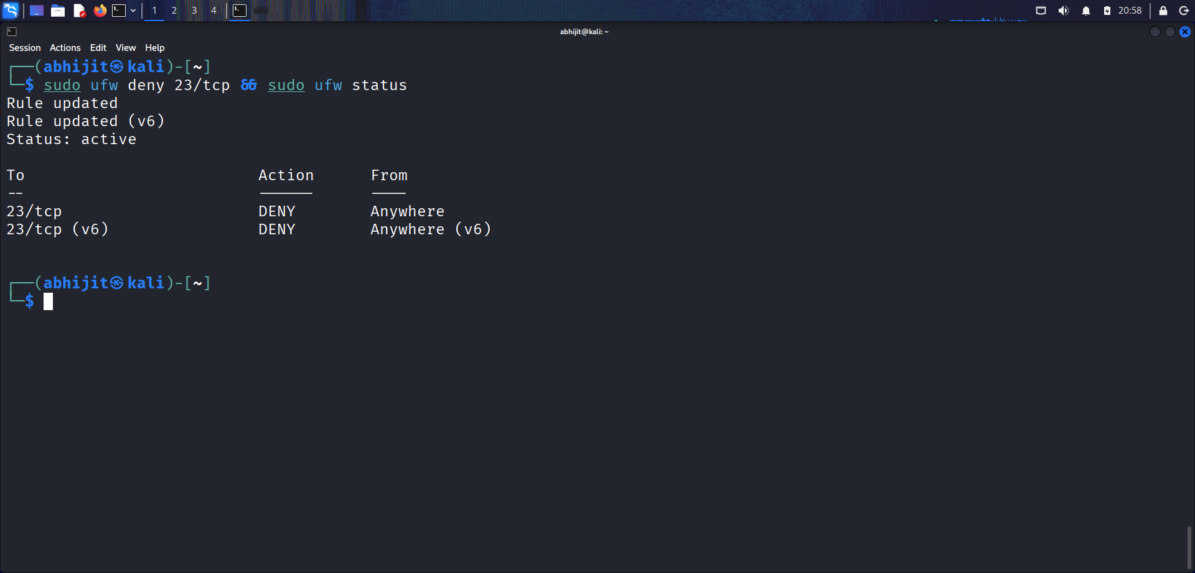

Test the Rule by Attempting to Connect to That Port Locally or Remotely

- Local Test (on the same machine):

Using Netcat on Linux & Try to connect.

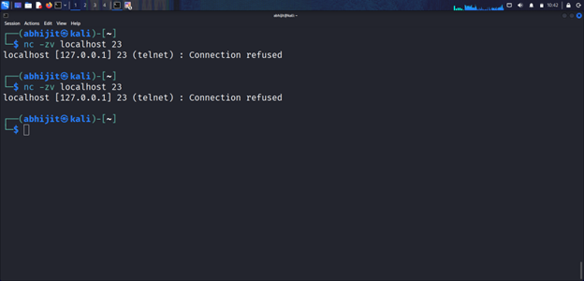

Reports:

Expected result: Connection should fail (e.g., "Connection refused" or timeout), confirming the block.

Add Rule to Allow SSH (Port 22) If on Linux

On Linux (UFW):

Run “sudo ufw allow 22/tcp” (allows inbound SSH). Confirm with “sudo ufw status”.

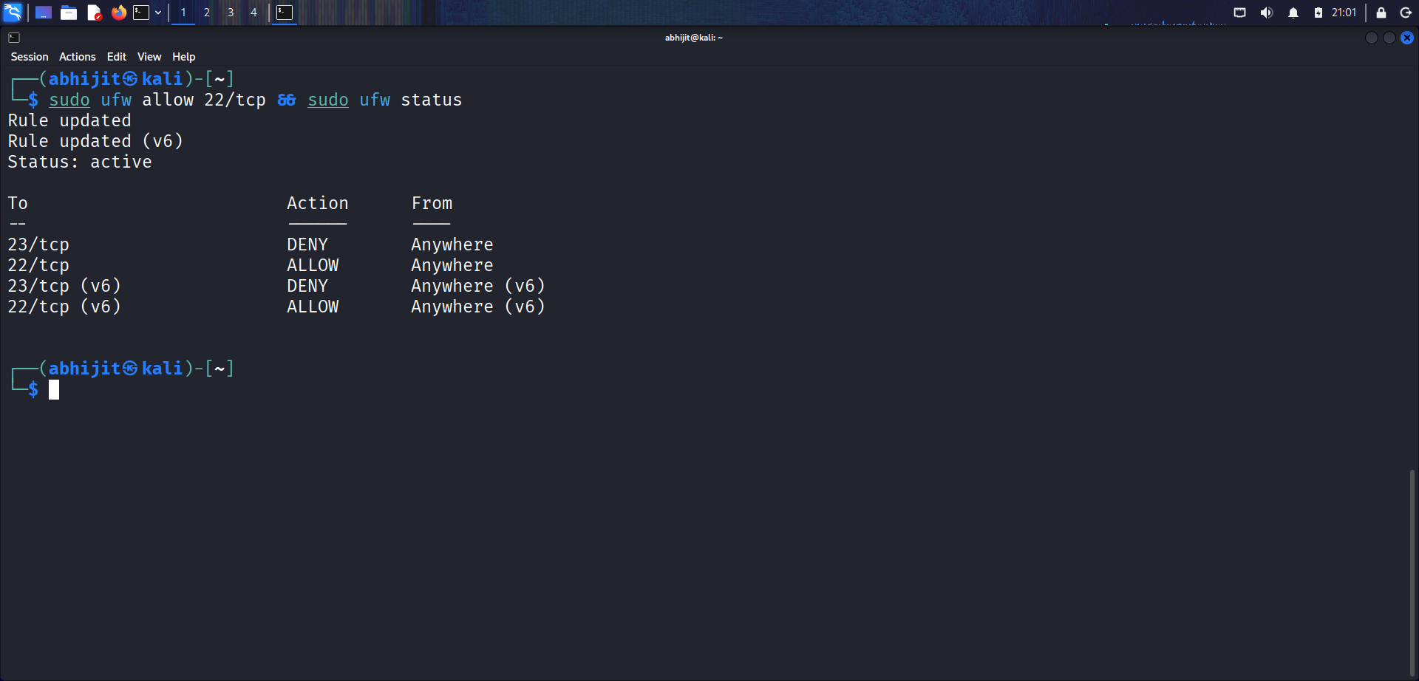

Test by connecting via SSH from another machine: ssh user@<your-IP>

Result:

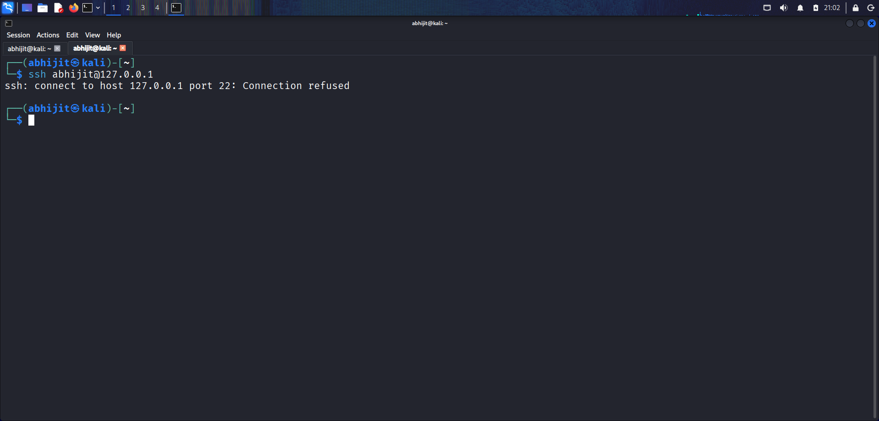
Connection Refused.

Remove the Test Block Rule to Restore Original State

On Linux (UFW):

Run “sudo ufw delete deny 23/tcp”. Confirm with “sudo ufw status”.

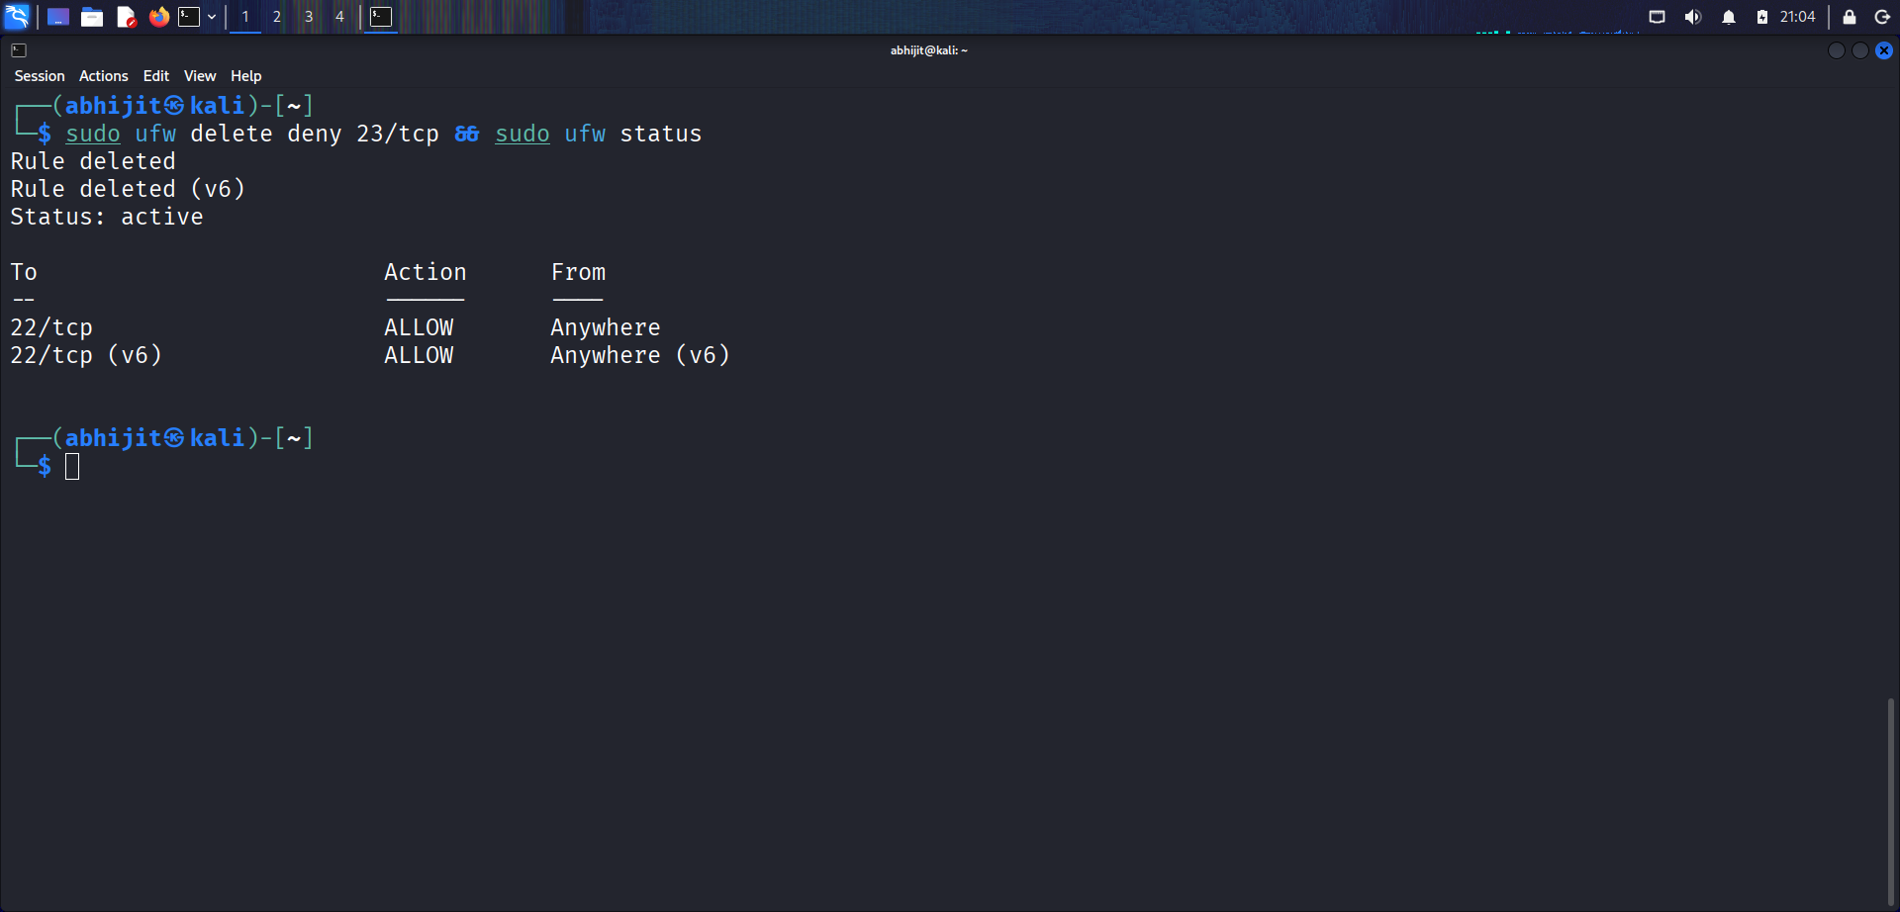

Document Commands or GUI Steps Used

Create a log file (e.g., text document) and record each step, including exact commands/GUI actions, timestamps, and outcomes.
Example:

Step 1: Opened firewall.cpl on Windows.
Step 2: Added inbound rule to block port 23 via GUI.
Step 3: Tested with nc -zv localhost 23; result: Connection refused.

This documentation helps track changes and troubleshoot.

Summarize How Firewall Filters Traffic

Firewalls act as a barrier between your system and the network, controlling inbound and outbound traffic based on rules. They filter packets by criteria like source/destination IP, port, protocol (e.g., TCP/UDP), and state (e.g., new vs. established connections). For example:

- Inbound Filtering: Blocks unwanted incoming connections (e.g., denying port 23 prevents Telnet access).

- Outbound Filtering: Restricts what your system can send out (less common but useful for malware prevention).

- Default Behavior: Most firewalls deny all inbound by default and allow outbound, requiring explicit "allow" rules for services like SSH.

- Stateful Inspection: Tracks connection states, allowing responses to outbound requests while blocking unsolicited inbound traffic. This layered approach enhances security by reducing attack surfaces, but over- restrictive rules can break functionality.

Thank You

